Module-6

(Bootstrap Basic & Advance)

1). What are the advantages of Bootstarp?

ANS. Advantages of Bootstrap:

* Easy to use : Anybody with just basic knowleage of HTML and CSS can start using Bootstrap
* Resonsive features: Bootstrap’s responsive CSS adjusts to phones, tablets, and Desktops
* Mobile-first approach: In boootstarp 3, mobile –first style are part of the subcore framework

2).What is aBootstrap container, and how does it work?

Ans. In Bootstrap ,container is used to set the content’s margins dealling with the responsive behaviors of your layout. It container of coloums(known as grid system). The container class is used to create boxed content.

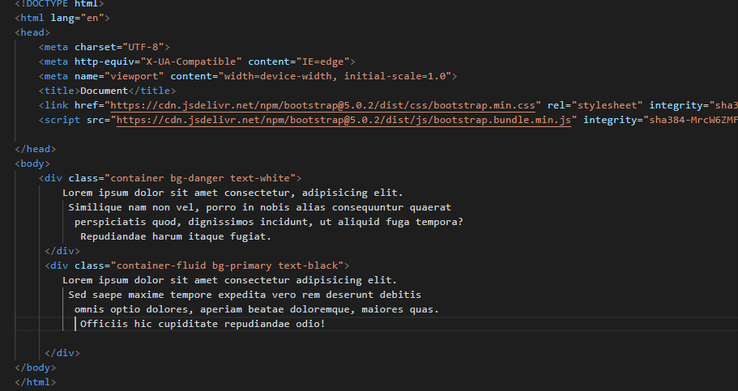

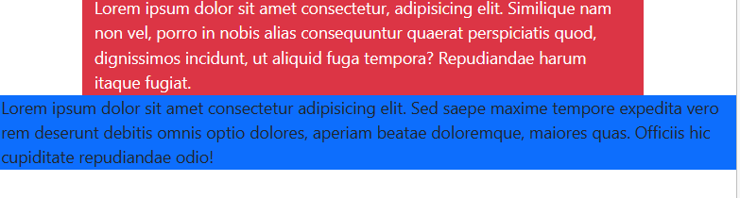

3).What are the default Bootstarp text settings?

Ans. Bootstrap 4 default settings

Bootstrap 4 uses a default font –size of 16px, and its line-hight is 1.5 . The default font-family is “Helvetica neue”, Arial ,sans-serif . In addition , all <p>elements have margin top:0 and margin –bottom :1rem (16 px by default).

4). What do you know about the Bootsrap grid system?

Ans. Bootstrap’s grid system uses a series of containers, rows, and coloums to layout and align content . it’s built with flexbox and is fully responsive . Below is an example and an in- depth look at how the grid comes together.

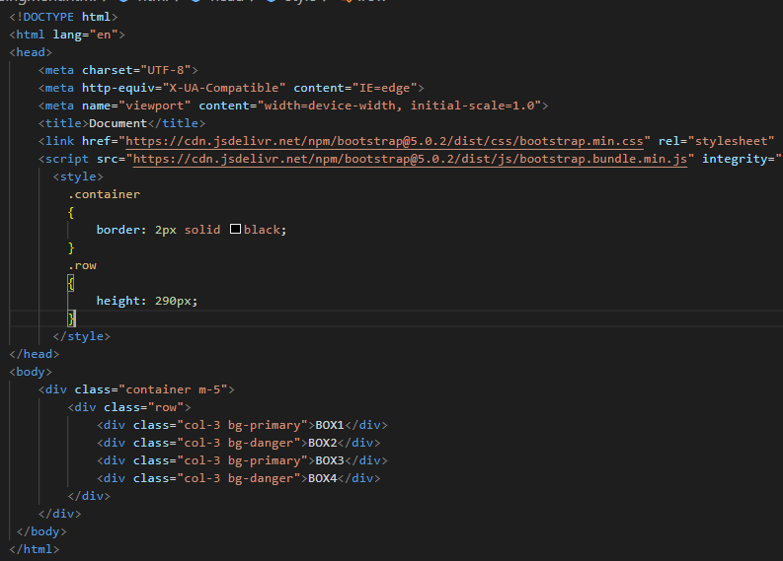

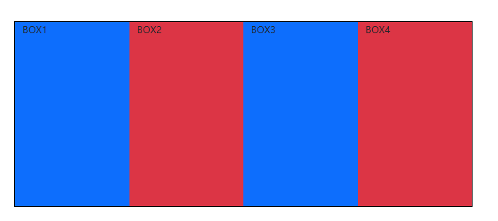

5).What is the difference between Bootstrap 4 and Bootstrap 5?

Ans. Bootstrap 4 uses Jekyll software. Bootstrap 5 uses Hugo software as it is fast static site generator.

This makes easier to implement vertical designs, and the columns and rows can easily be implemented. The classes justify-center-content can directly be used to align according to the requirement.

The main differences between Bootstrap 5 and Bootstrap 3&4, is that Bootstrap 5 has switched to Javascript instead of JQuery .

6). What is a Button group, and what is the class for a basic button group?

Ans. “Button groups” in Bootstrap is a class of name “btn-group” which is used to create series of buttons in groups (without spaces ) vertically or horizontally . This is the basic syntax of the button group class where each button has its own class of “btn”.

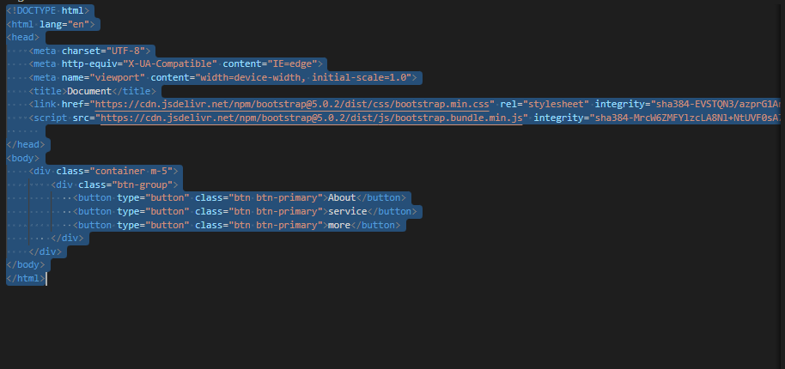

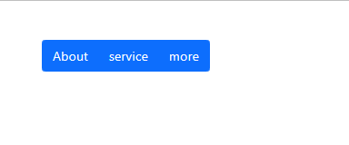

7).How can you use Bootstrap to make thumbnails?

Ans. Bootstrap –Thumbnails

1. Add <a> tag with class of thumbnail around an image.
2. This adds four pixies of padding and a gray border.
3. On hover, an animated glow outlines the image.

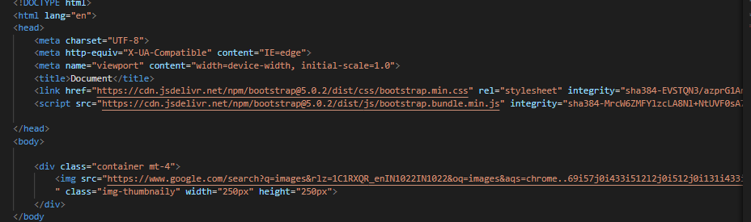

8). In Bootstrap 4, what is flexbox?

Ans. Flexbox The biggest difference between Bootstrap 3 and Bootstarp 4 is that Bootstrap 4 now uses flexbox , instead of floats, to handle the layout . The flexible responsive layout structure without using float or positioning.

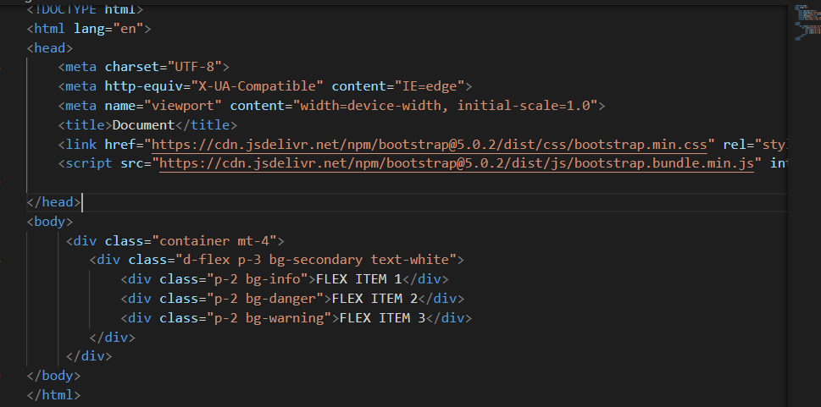



9).How can one create an alert in Bootstrap?

Ans. Here’s how:

* Be sure you’ve loaded the alert plugin , or the compiled Bootstrap Javascript.
* If you’re building our Javascript from source , it requires util. js The compiled version includes this.
* Add a dismiss button and the .alert –dismissiable class, which adds extra padding to the alert and positions the .close button.
* On the dismiss button , add the data-dismiss=”alert” attribute, which triggers the javascript functionality. Be sure to use the <boyyon>element with it for proper behaviour across all devises.
* To animate alerts when dismissing them , be sure to add the fade and show classes.

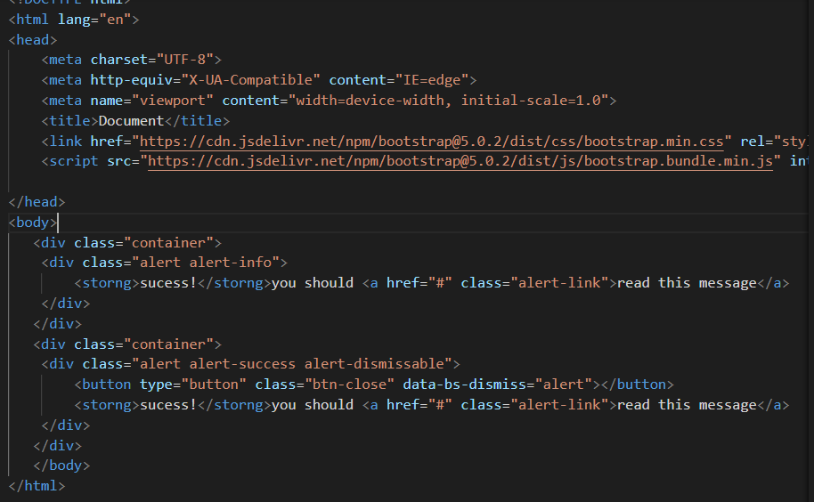

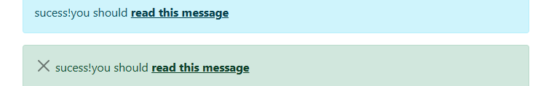

10). Wht is a Bootstrap card and how would you create one?

Ans. A card is a flexible and extensible content container. It includes option for headers and footers. A wide variety of content , contextual background colors , and powerful display options. If you’re familiar with Bootstrap 3, cards replace our old panles , wells ,and thumbanils.

